Topic 5.1

THERMODYNAMICS

Born-Haber Cycles
Solubility of Ionic Compounds in Water
Entropy Changes

CALCULATING ENTHALPY CHANGES

a) atomisation enthalpy and bond dissociation enthalpy

The enthalpy change for a chemical reaction can be deduced from consideration of the energy required to break bonds in the reactants and the energy released when the bonds in the products are formed.

By considering the relationship ΔH = E_{a}(forward) - E_{a}(reverse)
The enthalpy change for a chemical reaction can be calculated from the following equation:

ΔH = Energy required to break bonds in reactants - Energy required to break bonds in products.
Or ΔH = ΣΔH_{b}(bonds broken) - ΣΔH_{b}(bonds formed)

The energy required to separate all the bonds in an element or a compound is known as the atomisation enthalpy. It is defined slightly differently for elements and compounds.

The atomisation enthalpy of an element is the energy required to produce one mole of free gaseous atoms of that element.
Eg Na(s) → Na(g) or 1/2Cl₂(g) → Cl(g)

The atomisation enthalpy of a compound is the energy required to convert one mole of a compound into its free gaseous atoms.
Eg CH₄(g) → C(g) + 4H(g)

In gas phase reactions, the bonds which are broken and formed are covalent bonds. The energy required to separate completely the atoms in one mole of covalent bonds is known as the bond dissociation enthalpy of that bond (ΔH_{b}).

A-B(g) → A(g) + B(g)

Bond | ΔH /kJmol⁻¹
C-H | +413
O-H | +464
C-C | +347
C=C | +612
C=O | +805
H-F | +568
H-Cl | +432
Cl-Cl | +243
Br-Br | +193
O=O | +498

These bond enthalpies are mean values; the exact strength of a bond depends on its environment. Thus bond enthalpies calculated from different reactions may vary slightly.

b) Calculating approximate energy changes

The approximate ΔH of any reaction can be calculated, given bond dissociation enthalpies and atomisation enthalpies:

Eg Calculate the approximate energy change for the reaction:

CH₄(g) + 2O₂(g) → CO₂(g) + 2H₂O(g)

Bonds broken: 4 x C-H, 2 x 0=0
Energy required = 4(413) + 2(498) = 2648 kJmol⁻¹

Bonds formed: 2 x C=O, 4 x O-H
Energy released = 2(803), 4(464) = 3462 kJmol⁻¹

Energy change = 2648 – 3462 = -815 kJmol⁻¹

N.B Because the values used are mean bond energies, these calculations are only approximate. The value of the bond strengths in the substances involved in the reaction will be different from the mean values.

Calculations based on Hess’ Law do not rely on such approximations and so are more reliable
FORMATION OF IONIC COMPOUNDS

The enthalpy changes during reactions involving covalent compounds can be explained in terms of simple bond breaking and bond making:

ΔH = Σ(bonds broken) - Σ(bonds formed)

Reactions involving ionic compounds, however, involve a more complex sequence of processes and must be treated by a different method. Reactions involving the formation of ionic compounds from their elements can be broken down into three stages:
- formation of free gaseous atoms from the elements in their standard states.
- addition or removal of electrons to form ions.
- attraction of the ions to form the ionic compound.

Consider the reaction Na(s) + 1/2Cl₂(g) → NaCl(s)

a) Formation of free gaseous atoms from the elements in their standard states.

The enthalpy changes required to form free gaseous atoms can be obtained from the atomisation enthalpies or the bond dissociation enthalpies.

b) Formation of the ions from free gaseous atoms

The first ionisation energy of an atom is the energy required to remove one electron from each of a mole of free gaseous atoms of that element.
Eg Na(g) → Na⁺(g) + e

The first electron affinity of an atom is the energy change when one electron is added to each of a mole of free gaseous atoms of that element.
Eg Cl(g) + e → Cl⁻(g)

In cases where the ions have a charge of +2 or -2, other electrons must be transferred:

The second ionisation energy of an element is the energy required to remove one electron from each of a mole of free gaseous unipositive ions of that element:

Eg Mg⁺(g) → Mg²⁺(g) + e

The second electron affinity of an atom is the energy change when one electron is added to each of a mole of free gaseous uninegative ions of that element.

Eg O⁻(g) + e → O²⁻(g)

c) Attraction of the ions to form an ionic compound

The lattice enthalpy of an ionic compound is the energy released when one mole of the compound is formed from its free gaseous ions under standard conditions.

Eg Na⁺(g) + Cl⁻(g) → NaCl(s)

The formation of sodium chloride from sodium and chlorine thus consists of the following five processes:

Process | Equation | Enthalpy change/ kJmol⁻¹
Atomisation enthalpy of sodium | Na(s) → Na(g) | +107
Atomisation enthalpy of chlorine | 1/2Cl₂(g) → Cl(g) | +122
First ionisation energy of sodium | Na(g) → Na⁺(g) + e | +496
First electron affinity of chlorine | Cl(g) + e → Cl⁻(g) | -348
Lattice energy of sodium chloride | Na⁺(g) + Cl⁻(g) → NaCl(s) | -780

Atomisation enthalpies and ionisation enthalpies are always positive (ie endothermic). First electron affinities (usually) and lattice enthalpies are negative (ie exothermic).

The sequence of processes making up the formation of an ionic compound can be shown as an energetic cycle known as a Born-Haber cycle:
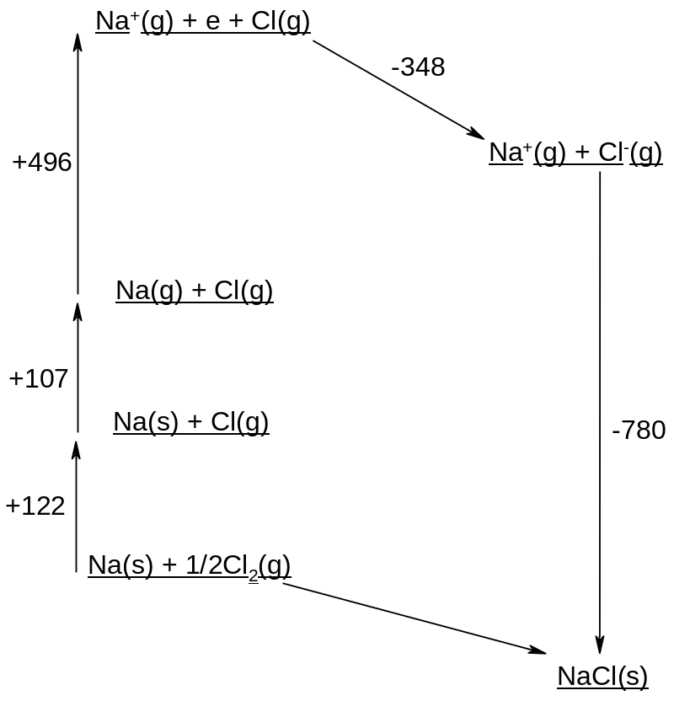

The enthalpy of formation of NaCl can be calculated from Hess' Law:

ΔH_{f}(NaCl) = +107 + 122 + 496 + (-348) + (-780) = -403 kJmol⁻¹.

Born-Haber cycles can be used to calculate any of the above processes if all the others are known. In practice it is usually used to calculate the electron affinity or the lattice enthalpy, since these are difficult processes to measure directly.

DISSOLVING IONIC COMPOUNDS

Ions are strongly attracted to water, since water is a polar molecule and so cations are attracted to the O atoms in water and anions are attracted to H atoms:

The energy released when a gaseous ion is dissolved in water is known as the hydration enthalpy of the ion:
M^{x+}(g) → M^{x+}(aq)

Not all ionic compounds are soluble, however, since the ions in the solid state are also attracted to each other (cf lattice energy). The energy required to break up an ionic lattice is known as the lattice dissociation enthalpy.

The enthalpy change when one mole of an ionic compound dissolves in excess water is known as the enthalpy of solution. The more exothermic the enthalpy of solution, the more likely the compound is to dissolve.

Eg NaCl(s) → NaCl(aq)

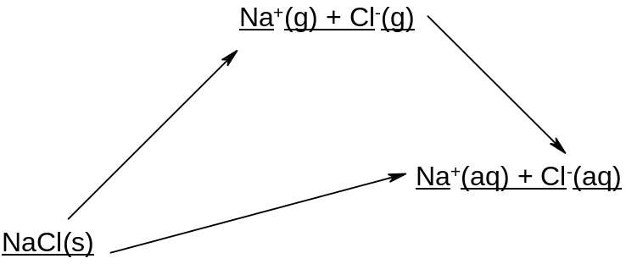

The hydration energy depends on the charge and the size of the ions: the larger the charge and the smaller the size, the larger the hydration energy.

Ion | Na⁺ | K⁺ | Mg²⁺ | Ca²⁺ | Cl⁻ | Br⁻
Hydration energy/kJmol⁻¹ | -406 | -322 | -1920 | -1650 | -364 | -337

.Solubility of ionic compounds in water thus varies widely, and depends on the balance between the hydration energy of the ions and the lattice energy of the compound. Most ionic compounds are at least partially soluble in water.

The solubility of ionic compounds can be calculated using the lattice energy of the compound and the hydration energy of the ions according to the following Hess' Law cycle:

∆H(solution) = Σ(∆H(hydration)) - ∆H(lattice formation)

or

∆H(solution) = Σ(∆H(hydration))+ ∆H(lattice dissociation)

eg for sodium chloride:
lattice dissociation enthalpy of NaCl: +780 kJmol⁻¹
hydration enthalpy of sodium ion: -406 kJmol⁻¹
hydration enthalpy of chloride ion: -364 kJmol⁻¹

enthalpy of solution of NaCl = 780 – 406 – 364 = +10 kJmol⁻¹

The greater the lattice energy, the harder it is to separate the ions and the lower the solubility. The greater the hydration energy, the greater the energy released when the ions dissolve in water and the greater the solubility.
SPONTANEOUS REACTIONS

It is often cited that reactions take place in order that the substances can become more stable (i.e. lower their potential energy). This is what happens during exothermic reactions. However this cannot be reconciled with the fact that many endothermic reactions proceed readily under normal conditions.

Two common endothermic reactions are:
NH₄Cl(s)→ NH₄Cl(aq) at room temperature
CaCO₃(s) → CaO(s) + CO₂(g) at temperatures above 1000ºC

It follows that there must be other factors, other than the enthalpy change, which determine whether or not a reaction will proceed spontaneously; the enthalpy change is important but not the only factor.

ENTROPY

The other factor which determines whether or not a reaction will take place is the change in entropy.

Entropy is a measure of the degree of disorder of a system.

A high degree of disorder makes a substance more stable.

Eg entropy increases solids < liquids < gases
Generally metals have a higher entropy than non-metallic solids

Typical entropy values are:

Substance | Entropy/ Jmol⁻¹K⁻¹
Diamond | 2.4
Graphite | 5.7
Aluminium | 28.3
Water | 69.9
Carbon monoxide | 197.6
Carbon dioxide | 213.6
Argon | 154.7

It is possible to calculate the entropy change for a reaction by applying the formula:

ΔS = ΣS_{products} - ΣS_{reactants}

eg Calculate the entropy change for the reaction C(s) + CO₂(g) → 2CO(g)

∆S = 2(197.6) – 213.6 – 5.7 = 175.9 Jmol⁻¹K⁻¹

If ∆S is +ve then a reaction is likely.
If ∆S is –ve then a reaction is unlikely.
Chemical reactions are favoured if they are accompanied by an increase in entropy.

Many endothermic reactions proceed spontaneously under normal conditions because there is an increase in entropy. Some exothermic reactions do not proceed spontaneously because there is a decrease in entropy.

FREE ENERGY

Whether or not a reaction will proceed thus depends on a balance between entropy and enthalpy. These two quantities combine to give a single term, known as free energy. The change in free energy of a reaction is the ultimate test of whether it will proceed.

∆G = ∆H - T∆S

∆G = change in free energy
∆H = change in enthalpy
∆S = change in entropy

If ∆G = -ve, the reaction will proceed, even if ∆H = +ve (though it may be very slow if the reactants have kinetic stability).

If ∆G = +ve, the reaction will not proceed, even if ∆H = -ve.

So enthalpy changes in chemical reactions are useful, but they cannot be used to predict whether or not a reaction will take place.

CRITICAL TEMPERATURE

Because the free energy change ∆G depends on T∆S, the effect of entropy becomes more important at higher temperatures.

If ∆H is –ve and ∆S is positive, the reaction will be spontaneous at all temperatures.
If ∆H is +ve and ∆S is negative, the reaction will not be spontaneous at any temperature.

However if ∆H and ∆S are both +ve, the reaction will be spontaneous only above a certain temperature. If ∆H and ∆S are both –ve, the reaction will be spontaneous only below a certain temperature.

The critical temperature is the temperature at which ∆G = 0, so ∆H = T∆S.

T = ∆H/∆S

